Computer Language Coding Concepts

Target Objects in a Diagram
The principle of target objects is explained in the article Target Objects. This article demonstrates its expression in a diagram.

The target object is the last point in a string of object reference redirections.

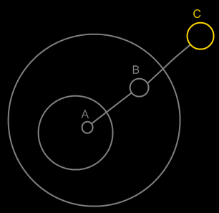

Symbol A is an object reference to symbol B. Symbol B is an object reference to symbol C. Symbol C is the target object of both symbols A and B.

The idea of target objects is also a way to make a single symbol
in the diagram represent the actual object, whereas the others are just seen as references to the object: to have the actual object only represented by a single symbol in the diagram.

See also: Target Objects

Author & Copyright: Jan-Joost van Zon Date: May 23, 2008 – June 19, 2008 Location: Oosterhout, The Netherlands Status: Finished

